There are two parts to this assignment.

**Part 1: Window OS Folder/File Access Permission Control**

This part is about managing file/folder access/permission control. In the cloud computing environment (open source, share, collaborative, security; then hacking, virus, infiltrations…), this is quite significant.

Execution Steps:

* On the Window OS environment, please demonstrate how you would control a folder, and a file access permission. Please capture screen shots, and a brief explanation by pasting it below.

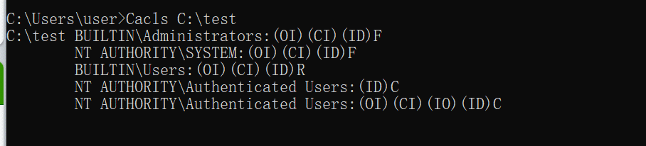

Access control permission items for the C:\ruery folder.

The letter at the end of each line indicates the control authority

"F" means full control, "C" means change, "W" means write. "R" means read

* On a Linux OS environment, please demonstrate how you would control a folder, and a file access permission. Please capture screen shots, and a brief explanation by pasting it below.

View file permissions

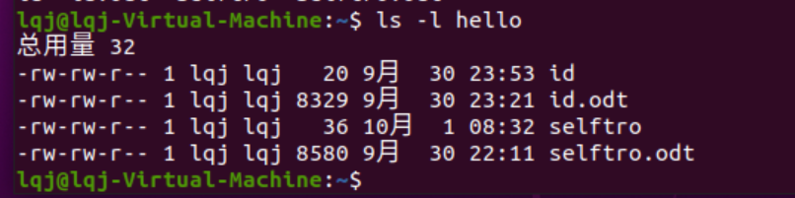

Change file permissions

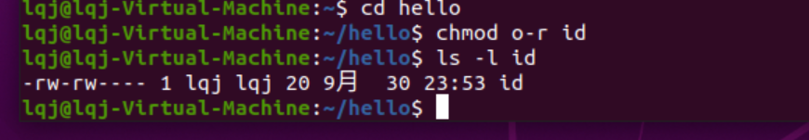

**Part 2: Explore Linux “screen” command**

This part is about ***managing a large number of computer systems (Data Center Scenario)***, the Linux way, using its “screen” utility function. How is the tech community addressing this issue? This is what I recommended to explore further:

<https://www.wired.com/story/how-to-organize-browser-tabs/>

Note: In case you don’t have a Linux Virtual Machine setup, please use this link to do the exercise.

<https://bellard.org/jslinux/vm.html?url=https://bellard.org/jslinux/buildroot-x86.cfg>

Execution Steps:

* Gain “root” authority by running the command: sudo -s

(If the command fail to execute, launch a new Linux shell and give it a fresh try.)

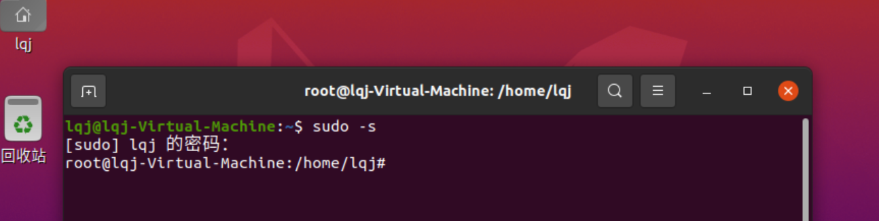

* Make sure your system supports the “screen” command. If not, open a Ubuntu/Linux session, and install “screen”: sudo apt-get install screen

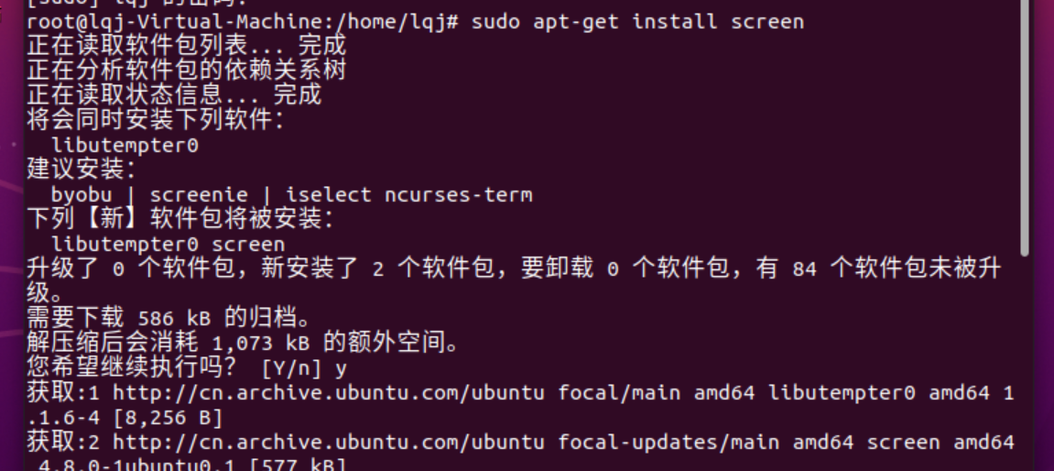

* cd ~; mkdir screen_dir;

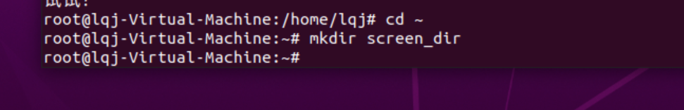

* Create the following file=”test1.screenrc”:

----------------------------------------------------------------------------

defscrollback 5000

logfile ~/datacenter_log_%n-%t.log

logfile flush 0

deflog on

sessionname: CM_Log_Servers

# List of computers under my control😊

screen -t "Session 1: ping Baidu" -L 1 ping www.baidu.com

screen -t "Session 2: ping Google" -L 2 ping www.google.com

screen -t "Session 3: ping SuzhouU" -L 3 ping www.suda.edu.cn

screen -t "Session 4: ping CityU" -L 4 ping www.cityu.edu

screen -t "Session 5: nano session" -L 5 nano nano_test

screen -t "Session 6: ssh session" -L 6 ssh root@10.0.0.55

screen -t "Session 7: telnet session" -L 7 telnet myhost.com

screen -t "Session 8: vim session" -L 8 vim vim_test

#....

#....

----------------------------------------------------------------------------

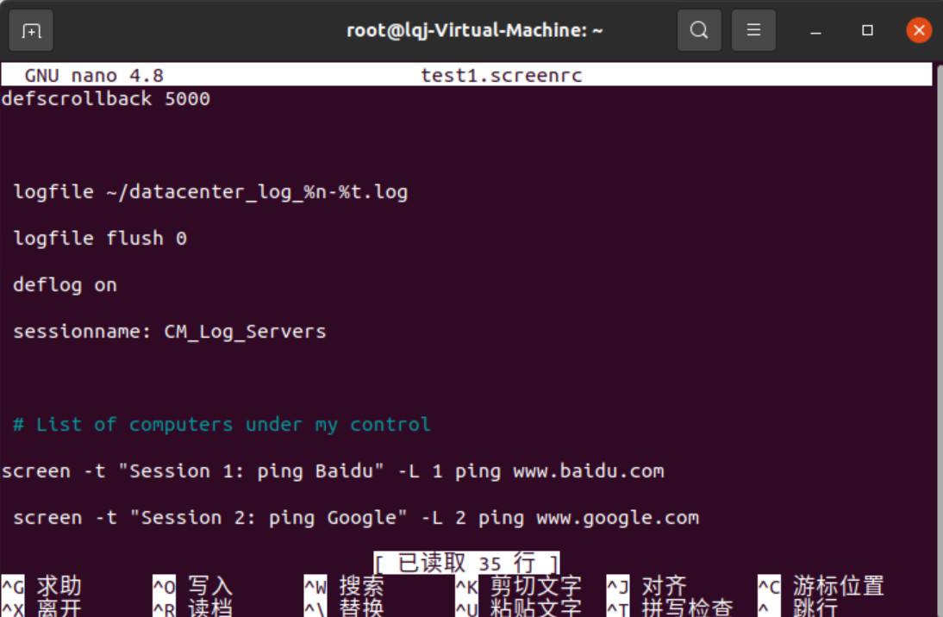

NOTES:

1. You can create as many Session as you desired.
2. “Dead” sessions will be dropped by default.
3. “ssh” usage model: <https://phoenixnap.com/kb/linux-ssh-commands>
4. “telnet” usage model: <https://www.computerhope.com/unix/utelnet.htm>

* Execute this command to launch your job: screen –c test1.screenrc

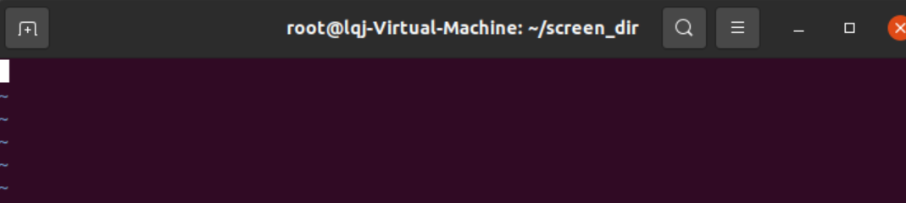

* Become familiar with the following screen commands and its keystrokes.

(Note: The keystrokes consist of *pressing 3 keys in 2-steps*. Step 1: “Ctrl” and “a” *together*. Step 2: The 3rd symbol/key. E.g. “. See additional examples below)

* + Ctrl a “ : List all the available sessions, computer nodes.

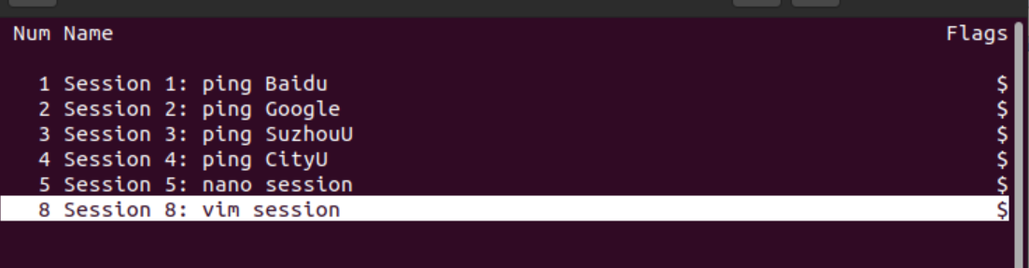

* + Navigate to your desire session with the Up/Down arrow key, then hit Enter-key.

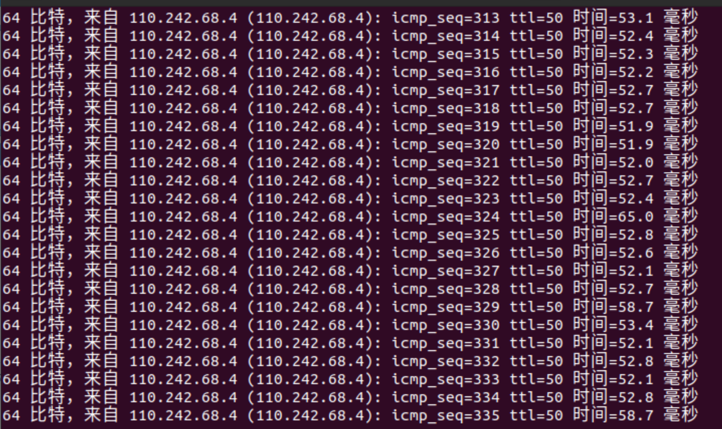

* + Ctrl a ? : Open help screen manuals.

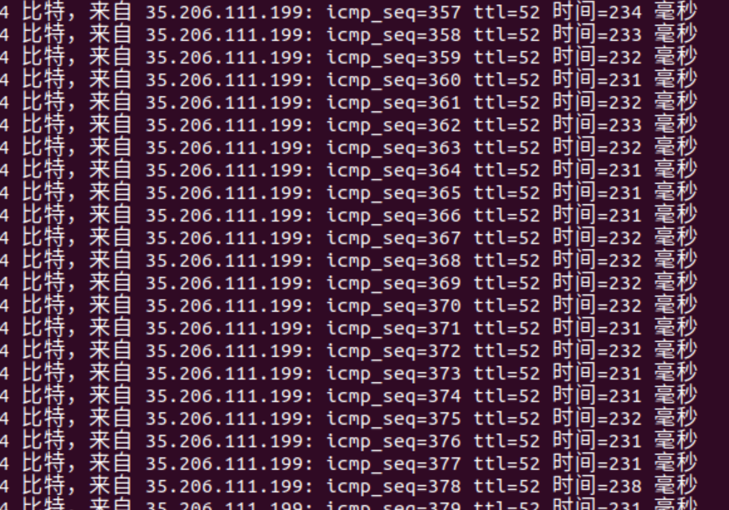

* + Ctrl a \ : To kill the screen session management utility.



* *Navigate to all 3 sessions and capture your screen shots below.*

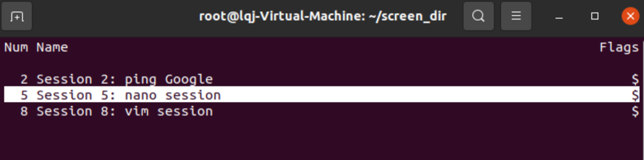

* Explore further “screen” features by visiting this website: <https://linuxize.com/post/how-to-use-linux-screen/>

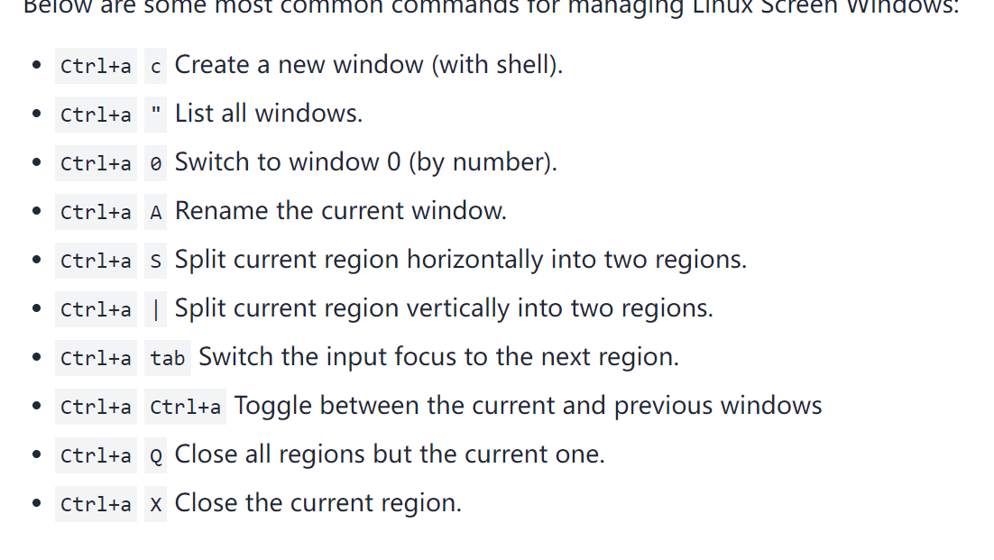

* Explore any other tools to manage, for example, 100 computers. The tool needs to have the ability to navigate to a specific node, with fewest keystrokes, or clicks possible. Please share your findings.

Python

Regular expression

Visual studio

**Lab Results Submission:**

Please post your screenshots, and elaborations to this document, then submit to online. If that fails, please email to: bangpanliang@gmail.com

The email subject should include [your StudentID, Assignment Name]

End of this Lab!